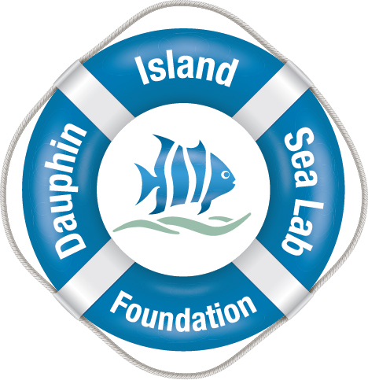

Yes, I’d like to become a friend of the Dauphin Island Sea Lab!

Please check one:

Basic Levels: ___Student ($30) ___Individual ($50) ___Family($100)

Advanced Levels:____Seahorse($250) ____Skate($500) ____Starfish($1000) ____School of Fish($2500)
______________________________________________
Name

______________________________________________
Address

______________________________________________
City, State, Zip

______________________________________________
Phone number

Email Address

Credit Card Information:

# ____________________________Exp. Date_________ CVV_______________

Please Consider An Additional Donation:$_____________

Please print out this form and mail to:
Please make check payable to: The Dauphin Island Sea Lab Foundation (DISLF) P.O. Box 82151 Mobile, AL 36689-2151

