**Dauphin Island Sea Lab Foundation**

**Annual Overview**

**2014-2015**

**Financial Information**

DISLF began FY 2014-2015 with a Total Checking and Savings balance of $173,504.56. The Community Foundation had a balance of $**713,771.05** for total assets of **$887,275.61.**

Ending balances for 2014-2015 for Total Checking and Savings was $219,109.31. Community Foundation had a total of $803,030.54 for total assets of $**1,022,139.85** an increase of 13% over LY.

$70,000 will be transferred to the endowment. The addition will be made in a lump sum to the total account.

**George Crozier Endowment**

During the audit of the Marine Environmental Consortium (MESC) finances in early 2014 it was discovered that the original documents to set up the CFSA Kresge grant which, were signed by George Crozier, the Executive Director of the MESC, for the MESC in Jan. 2002. The Dauphin Island Sea Lab Foundation was founded in February 2002 with the intent to raise the money for the Kresge match and in general grow and manage the Endowment. The DISLF has been functioning for twelve years as the owner of the Endowment while in fact the Endowment had never been transferred to the Foundation’s ownership.

The transfer of the ownership of the George Crozier Endowment from the MESC to the DISLF was finalized in April 2015. The transfer was overseen by Tom Gaillard as attorney, John Valentine as the executive Director the MESC and Linette Clausen the CFO of the Community Foundation of south Alabama.

**Fundraising**

**Grants:**

* *The Glaze Foundation* –
* Poarch Creek Gaming Foundation underwrote MEAL
* Hearin Chandler donated funds for a new Introductory Film to be produced at the Estuarium
* Crampton Trust donated funds for a new Vernier Testing system for the Discovery Hall Program
* Wells Fargo donated funds for the new Vernier Testing system for the Discovery Hall Program

**Marine Environmental Awards Luncheon (MEAL):**

The MEAL was held November 3 at the Battlehouse Hotel. Our Speaker was David Gallo, professor at Woods Hole. He was one of the first oceanographers to use a combination of manned submersibles and robots to map the ocean floor world with unprecedented clarity and detail.. Most recently he co-led an expedition to create the first detailed and comprehensive map of the RMS *Titanic* and he co-led the successful international effort to locate the wreck site of Air France flight 447.

Tickets were $50. 238 people were in attendance.

Gulf Coast Marine Environmental Excellence Award-Recognizes an individual who has made outstanding contributions to marine environmental sustainability in the Alabama Gulf Coast Region. Winner: **Ann Bedsole**

Gulf Coast Marine Environmental Leadership Award-Recognizes a business or organization whose efforts have resulted in the improvement of marine environmental sustainability in the Alabama Gulf Coast Region. Winner: **Mobile Big Game Fishing Club**

The selection committee comprised of John Valentine, John Dindo, Russell Ladd, John Goodloe, Scott Heggeman, Patrick Wilson and Helene Hassell evaluated the nominees and unanimously chose the recipients.

**Income and Expense Report Meal**

|  |  |
| --- | --- |
| **Expenses** | **2014** |
| Battlehouse Food & AV | $8,424.60 |
| Speaker Total | $5,753.00 |
| Gift | $270.00 |
| Printing/publicity | $721.29 |
| Door Prize | $0.00 |
| Books | $0.00 |
| Flowers | $330.00 |
| Office depot | $42.13 |
| **Total Expenses** | **$15,541.02** |
|  |  |
| **Income** |  |
| WindCreek | $5,000.00 |
| Tables | $8,350.00 |
| Individuals | $3,050.00 |
| Book Sales | $0.00 |
| Books to Gift shop | $0.00 |
| Donations | $1,140.00 |
| Flower sales | $402.00 |
| Total Income | **$17,942.00** |
|  |  |
| Net | **$2,400.98** |

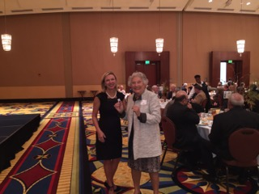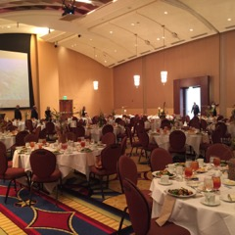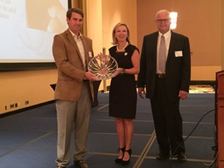

**Friends of the Sea Lab**

|  |  |  |  |  |  |  |  |  |  |  |  |  |
| --- | --- | --- | --- | --- | --- | --- | --- | --- | --- | --- | --- | --- |
|  | 2010-2011 | | 2011-2012 | | 2012-2013 | | 2013-2014 | |  | | 2014-2015 | |
| Students | 1 | $30.00 | 1 | $30.00 | 0 |  | 1 | $30.00 | |  | 1 | $30.00 |
| Individual | 8 | $400.00 | 9 | $450.00 | 10 | $500.00 | 10 | $500.00 | |  | 6 | $300.00 |
| Family | 53 | $5,300.00 | 44 | $4,400.00 | 91 | $9,100 | 89 | $8,900.00 | |  | 109 | $10,800.00 |
| Seahorse | 5 | $1,250.00 | 3 | $750.00 | 10 | $2,500.00 | 7 | $1,750.00 | |  | 12 | $3,000.00 |
| Skate | 2 | $1,000.00 | 3 | $1,500.00 | 5 | $2,500.00 | 1 | $500.00 | |  | 2 | $1,000.00 |
| starfish | 0 | $0.00 | 1 | $1,000.00 | 1 | $1,000.00 | 1 | $1,000.00 | |  | 0 |  |
| School of fish | 1 | $2,500.00 | 2 | $5,000.00 | 2 | $,5000.00 | 2 | $5,000.00 | |  | 1 | $2,500.00 |
| Comps | 0 |  | 0 |  | 4 |  | 7 |  | |  | 5 |  |
| *Totals* | *70* | *$10,480.00* | *63* | *$13,130.00* | *123* | *$20,600* | *124* | *$17,680.00* | |  | *136* | *$17,630.00* |

730 letters were mailed in August and included the MEAL save the date card. Letters are mailed bi-monthly to remind “Friends” that their memberships are about to expire.

**Christmas Appeal:**

The holiday appeal grossed $9165 with expenses of $627 for a net profit of $8,537. 786 letters were mailed.

|  |  |  |  |  |  |
| --- | --- | --- | --- | --- | --- |
|  | **2010-2011** | **2011-2012** | **2012-2013** | **2013-2014** | **2014-2015** |
| Gross Income | $6,150.00 | $6,395.00 | $6,001.57 | $6,400 | $9165.00 |
| Expenses | $462.36 | $653.27 | $ 350 | 653.27 | $ 627.26 |
| Net income | $5,687.64 | $5,741.73 | $5,651.57 | $5,741.73 | $8537.74 |
|  |  |  |  |  |  |
| Letters | 650 | 805 | 750 | 786 | 840 |
| Donors | 32 | 35 | 34 | 30 | 53 |

**Cocktails with the Critters**

The tenth annual CWC was held May 7 at THE BLUE GILL on the Causeway. This was the second year at The Blue Gill. Our attendance was 450 again this year. Eric Erdman provided music and Stig Marcussen was our featured artist. Tickets were $50 in advance and $55 at the door.

|  |  |  |  |  |  |  |
| --- | --- | --- | --- | --- | --- | --- |
| **Income and Expense for Cocktails with the Critters** | 2015 | 2014 | 2013 | 2012 | 2011 | 2010 |
| **Income** |  |  |  |  |  |  |
| Tickets-Gate | $3,685 | $3,035 | $2,605 | $3,450 | $2,600 |  |
| Adv. Ticket Sales | $5,400 | $5,150 | $7,450 | $7,307 | $6,200 | $7,900 |
| Individual sponsors | $6,250 | $7,750 | $6,750 | $9,050 | $6,250 |  |
| Corporate Sponsorship | $42,500 | $37,050 | $37,250 | $30,250 | $24,000 | $28,200 |
| Trustee Sponsorship | $4,600 | $4,550 | $4,450 | $4,600 | $3,400 |  |
| Silent Auction | $22,736 | $21,182 | $26,000 | $19,925 | $10,905 | $5,600 |
| Artist | $400 | $885 | $2,235 | $955 | $1,800 |  |
| T-Shirts | $0 | $1,239 | $1,009 | $400 |  |  |
| Balloon Pop | $600 |  |  |  |  |  |
| Donations | $850 | $1,600 | $1,150 |  |  | $393 |
| **Total Income** | **$87,021** | **$82,441** | **$88,899** | **$75,537** | **$55,155** | **$42,093** |
|  |  |  |  |  |  |  |
| **Expenses** |  |  |  |  |  |  |
| Printing | $798 | $812 | $1,054 | $1,262 | $1,224 | $1,219 |
| Postage | $338 | $321 | $358 | $187 | $215 | $109 |
| Publicity | $600 | $450 | $450 | $450 |  |  |
| Band | $500 | $1,500 | $1,500 | $1,500 | $2,000 | $600 |
| Food(tx+grat) | $10,684 | $10,344 | $11,192 | $8,706 | $5,400 | $5,556 |
| Beverage | $4,534 | $2,745 | $4,048 | $3,420 | $3,450 | $1,018 |
| Decorations | $0 |  |  |  | $155 | $100 |
| Tent rental | $0 |  | $393 | $655 | $302 | $350 |
| Lighting | $200 |  | $174 | $130 | $240 |  |
| Credit Card Fees | $0 |  |  |  | $233 | $132 |
| Policeman | $0 | $100 | $90 |  |  |  |
| PayPal fees | $676 | $493 | $324 |  |  |  |
| Reimburse Artist | $200 | $443 | $1,118 | $478 | $1,075 |  |
| Other | $423 |  | $371 |  |  | $100 |
| Silent Auction Consignment | $900 | $1,775 | $1,770 | $2,421 |  |  |
| Ribbons | $264 | $240 | $126 |  |  |  |
| Silent Auction |  |  | $0 | $125 | $250 | $228 |
| *Total Expenses* | $20,116 | $19,223 | $22,968 | *$19,334* | *$14,544* | *$9,412* |
| **Net Income** | **$66,905** | ***$63,218*** | **$65,931** | **$56,203** | **$40,611** | **$32,681** |

**In-kind sponsors**

1. WKRG $20,000 to $30,000 worth of airtime!!!!! And they have agreed to do it again next year.

2. Gwin’s who has done most of our printing in the past agreed to give us a 40% discount on anything they could put their name on.

3. Carpe Diem-We rewarded Carpe Diem with a sponsorship this year since they let us use their meeting room free of charge for our monthly meetings

4. Lagniappe- Tickets were given for a free ad.

5. Blue Rents- Entry tent and Helium balloon tank.

***Silent Auction –***This year’s auction generated a gross revenue of **$22**,**736** less consignment costs of **$900** resulting in net sales of **$21,836** from 124 items, giving us a 15% increase over LY. The FMV of the items this year totaled $41,616 an increase of $5,677 over 2014.

**~~~~~~~~~~~~~~~~~~~~~~~~~~~~~~~~~~~~~~~~~~~~~~~~~~~~**

**Grand Total Net Profit generated for the Sea Lab Foundation -**

**$67,055 resulting in a 6% increase over LY.**

**~~~~~~~~~~~~~~~~~~~~~~~~~~~~~~~~~~~~~~~~~~~~~~~~~~~**

**New Additions:**

1. Balloon Pop- Several items, which were donated, had a value of $25 or less. These items were included in the BP. We inserted a tag for each item into a balloon, filled it with helium and tied it to the rail. Balloon pops were sold at $20 per pop. We purchased a few items to round out the BP. A case of wine and several barbequing tools were purchased. We made $600 on this event. Grant Harkness donated the helium tank. The Balloon Pop was totally set up and run by the grad students.
2. A catalog was printed front and back listing the items and donors as well as the Silent Auction schedule.
3. Will Bridges of Willow Bridges came and added lighting to the Silent Auction area. It was a major improvement.

**In conclusion**:

We met all of our goals from last year and CWC continues to be an event that is considered by those in the community to be a fun and worthwhile event.

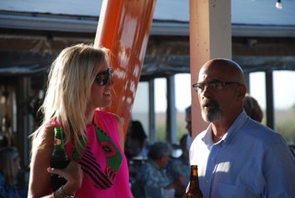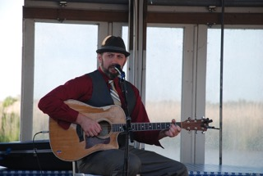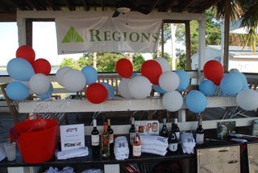

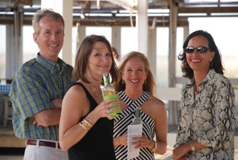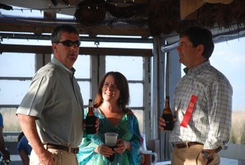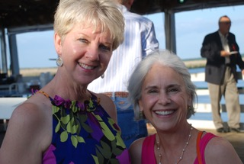

**Trustees**

Bryan Thames, Chair

Mary Ellingwood, V. Chair

Scott Browning, Treas.

Margaret VanLoock, Sec.

Walsh Arendall

Kinley Bell

Bob Collins

Rick Courtney

Kevin Cross

Fred Cushing

George Davis

John Dindo

David England

Russ Ford

John Goodloe

Bill Haffner

Grant Harkness

Scott Heggeman

John B. Howell, IV

Luella Hunt

Neil Kennedy

Russell Ladd

Angela Payne

Julie Sirmon

Jay Thompson

Richard Tremayne

Bud Urquhart

John Valentine

Marc Whitehead

**Advisory Committee**

Erin Wheeler –Chairman

Karlos Finley, V. Chair

Melissa Baker

Fred Brock

Goldie Burkholder

Suzanne Damrich

Tom Gaillard

Lisa Goodloe

Dr. Robert Harlin

Doug Hungerford

Ben King

Austill Lott

Tara Marshall

Tomi Sue Mayer

Dottie McKean

Eliska Morgan

Sonny Middleton

Jocko Potts

Chuck Stapleton

Marty Stapleton

Partick Wilson

**Tours:** John Valentine, John Dindo along with Helene hosted tours of the Sea Lab for the following people:

Wells Fargo Executives

Ben King

Johnny and Molly Hunter

Erin Wheeler

Robin Linn

The DISLF Sponsored:

The DISL Graduate Student Symposium

Bays and Bayous hosted by the Mobile Bay National Estuary Program

Respectively Submitted,

Helene Hassell

Executive Director